Creating a User-Printable Three-Rate Rain Gauge Calibration System

J. M. Lopez Alcala1, C. J. Udell 1 J. S. Selker1,2

1 Openly Published Environmental Sensing Laboratory, Oregon State University, Corvallis, Oregon, USA,2 Department of Biological and Ecological Engineering, Oregon State University, Corvallis, USA

Corresponding author: John Selker ([John.Selker@oregonstate.edu)](mailto:John.Selker@oregonstate.edu))

Key Points:

* Developed a rain-gauge calibrator delivering volumetrically precise (<0.1% error) volumes of water.
* This design is easily adapted to any gauge, and fully accessible to be produced on most 3D printers anyone in the world.
* Parametric open-source design permits users to customize the calibrator to their rain gauges.

Abstract

The objective of this project was to develop and validate a freely downloadable, open-source, 3D printed rain gauge calibrator that can be adjusted for a wide range of gauges. The proposed calibrator provides for applying low, medium, and high intensity flow, and allows the user to modify the design to conform to unique system specifications based on parametric design code, which may be modified and printed using CAD software. Currently available devices for this purpose tend to be designed for specific rain gauges, are expensive, employ low-precision water reservoirs, and do not offer the flexibility needed to test the ever more popular small-aperture rain gauges. To overcome the fact that different 3D printers yield different surface qualities, we devised a simple post-printing step that controlled the most sensitive dimensions to assure robust performance. Specifically, the three orifices of the calibrator are drilled to reach the three target flow rates. Laboratory tests showed that flow rates were consistent between prints, and between trials of each part, while the total applied water was precisely controlled by the use of a volumetric flask as the reservoir.

1 Introduction

Rain gauges are used commonly around the world and come in a variety of shapes and sizes. These devices are essential tools for high-quality and reliable observation of precipitation. They are the most explicit method for surface rainfall data collection utilized for hydrological, climatological, and agricultural studies [*Habib et al., 2012*]. Such studies call for reliable and accurate data to be able to produce proper predictions of upcoming climate changes. These devices are essential instruments in the field and must be robust and dependable for data acquisition, given that they are responsible for collection of crucial measurements. The following question arises concerning the validity of the sampler: “How do we know that the sampler is correctly reporting the rainfall amount, and are we sure that the total amount reported is not a function of the rate of rainfall?” [*Bergmann et al.*, 2001]. To validate the integrity of the rain gauge requires the application of a known constant flow rate and volume. Such devices already exist but have important limitations. Some employ simple gravity fed inverted bottles wherein the rate of flow decreases with the depletion of the water supply, and thus do not provide a constant rate of application. Others are tuned to specific size rain gauges, applying rates of flow and requiring mechanical attachment that is not adaptable to alternative sizes and shapes of rain collectors. In our case, the collection area of our rain gauge was smaller than those for which calibration tools had been developed, requiring that we develop a design capable of delivering lower rates of application. Custom calibrators may include a setup of programmable pumps, loggers, digital scales and computers to be able to adequately perform the calibration of the rain gauge [*Humphrey et al.,1997*]. With numerous external instruments, time is wasted reprogramming some of the devices with new parameters just to make it function with a different rain gauge. In terms of adaptability not currently seen in most calibration equipment, we seek to provide a system that can be easily modified to be able to meet new rain gauge design specifications and fitted to any given rain gauge geometry. Finally, we seek to remove the constraints of the high cost of many calibration solutions, and the requirement to return a rain gauge to the lab to conduct calibration [*Bergmann et al.*, 2001; *Vasvári*, 2005]. Thus, we saw the need to develop a rain gauge calibration system that was low-cost, easily customized, provided a user-definable range of constant flow rates, and was easily employed in the field.

Achieving constant flow rate is key for rain gauge calibration systems. A robust passive approach that delivers a constant flow rate is the Mariotte bottle. A typical Mariotte bottle setup has a container with a tube coming in from the top for air and an orifice on the side of the container for the liquid output. The bottle is designed to deliver a constant flow of liquid proportional to the distance between the bottom of the air inlet and liquid outlet and outlet orifice diameter.

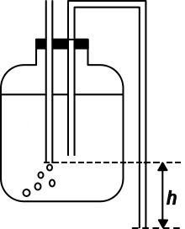

Figure 1. Standard Mariotte bottle design wherein for low flow rates the outlet head is constant at a value *h*, as long as both tubes are submerged and flow has been established.

Our design employs the Mariotte bottle principle with the bottle inverted, and both tubes formed into an O-ring sealed element we refer as “Mariotte stoppers” that fits into the top of a volumetric flask. Multiple flow rates were achieved in the same device by placing three Mariotte stoppers held on the plate that rests in the rain gauge. Each Marriot stopper is conical with two orifices on the top, a short-path air inlet and a long-path liquid outlet, with1/2 of the cone suppressed towards the core; the suppressed section goes from the core to the outside in the direction of the air inlet. The suppression of one of the sides is to facilitate the flow of air into the bottle and limit the path it must travel to enter. The side that is not suppressed gives the calibrator the change in height, from the air inlet to liquid outlet, required to dictate the flow rate (figure 2). The rate of outflow is dictated by the combination of the constant head, and the three different aperture outlets.

2 Materials and Methods

The three-rate calibrator was first designed and printed using the code found in Supplement 1, written in the open-source program OpenSCAD (2016). The design was later transferred to Fusion 360(figure 2), a more powerful tool for CAD. The new version of the design offered a more user-friendly interface to be able to easily edit the design.

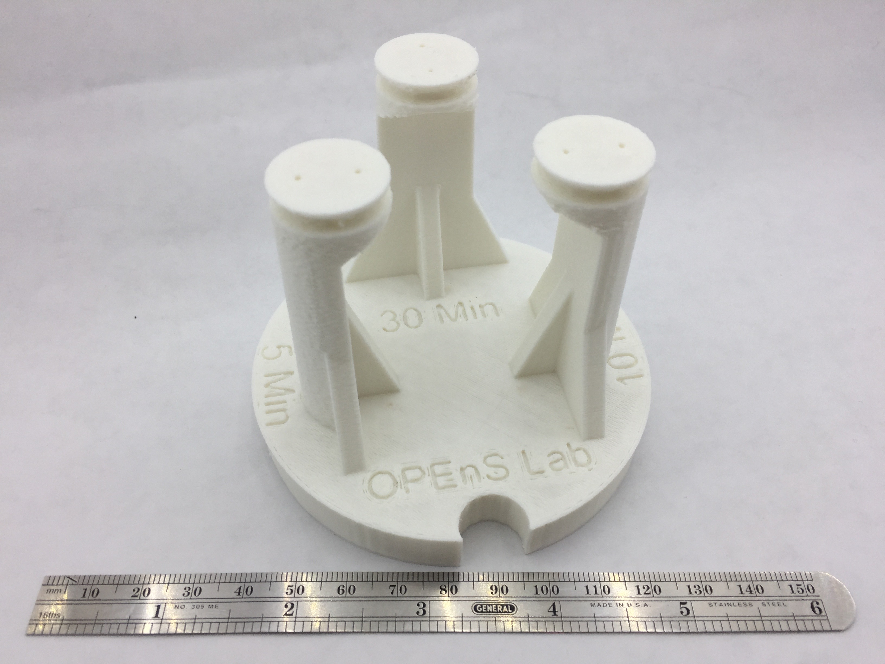

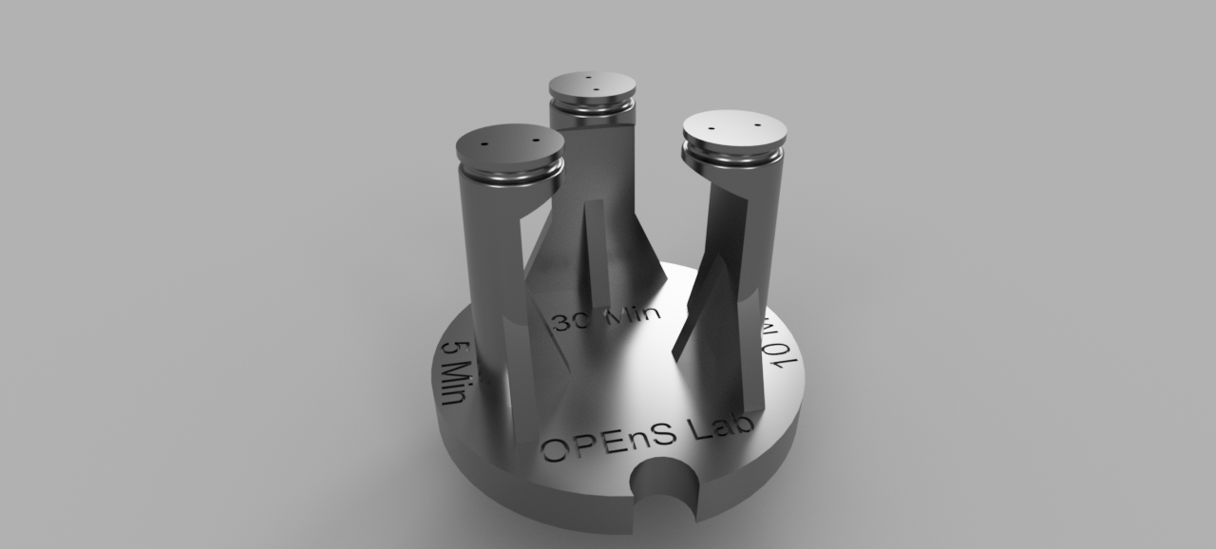

1. (b)

**Figure 2**: Three setting Mariotte stopper plate design (a). Each stopper has an air inlet port and a water outlet port. The diameter of the outlet pipes, which is established by drilling out the holes post-printing (b), is the primary control on the outlet rate.

The calibrator has three Mariotte stoppers on a plate that has a circular cutout to accommodate the solar radiation sensor that is located within the rain collector in the device for which was designed.

The reservoir of water employed in the test was a 500 ml (+/- 0.2 ml, or +/- 0.04%; Volumetric, 2016) volumetric flask made from polypropylene, as purchased on-line for under $5. Volumetric flasks of 100, 250, and 1000 ml are available with the same size openings, allowing a variety of total volumes of water delivery.

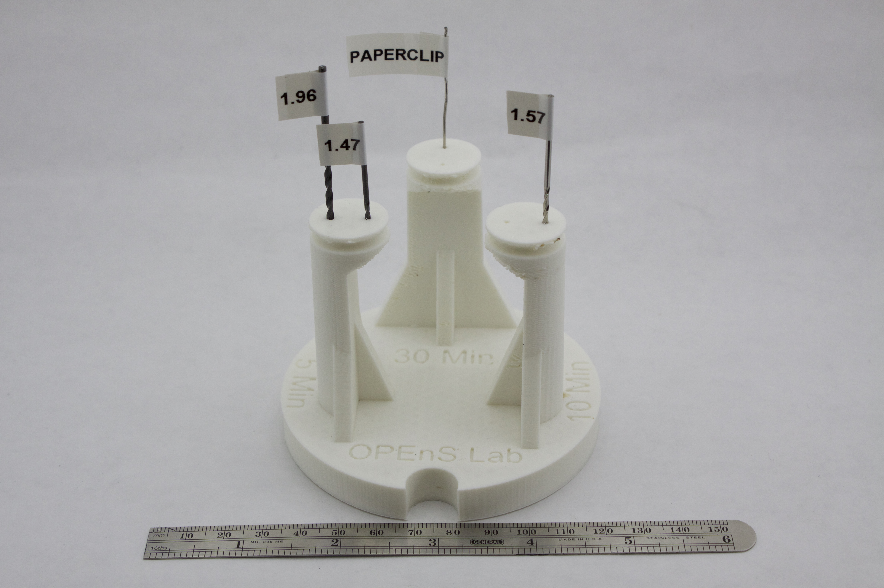

Figure 3. Calibrator demonstrating the used drill bits in their corresponding holes.

At the OPEnS lab (Open-sensing.org), we employed two printers to confirm multi-platform production capability: a Lulzbot TAZ5 and a Fusion3 F400. All parts were printed from Acrylonitrile Butadiene Styrene (ABS) plastic filament. After cooling, the precise diameter of the water outlet and air inlet apertures were established by drilling out the excess plastic. The drill bits are from a standard set but the actual dimensions of the bits are labeled in Figure 3. The five-minute setting was drilled with a 1.47mm drill bit for the air inlet and a 1.96mm drill bit for the water outlet; standard set labeled them as 1.5mm and 2.0mm respectively. The ten-minute setting employed a 1.57mm drill bit for both orifices; standard set label read 1/16 inch. To illustrate the importance of precise re-finishing of the orifices, in the case of the thirty-minute setting the printed holes were only cleaned out with a 0.85mm diameter paper clip. In production, we recommend that orifice be printed with hole of 0.60 mm diameter drilled out to 0.85mm.

3 Data and Results

Every calibrator printed at the OPEnS lab is tested to confirm performance. The graph presented in this paper is an example of the trials performed on three calibrators where two of the three critical apertures were drilled, and the 30-minute delivery hole left as printed (Figure 3).

**Figure 4.** Times (minutes) of delivery for 500ml of water obtained for the three calibration settings on three printed calibrators. Three calibrators were tested three times each at each setting (all data listed, grouped by the unit under test). The left two devices tested were printed on the Taz5 and the right point on the Fusion3.

From the collected data, we can observe that the five and ten minute settings are consistent to within 3%, while the use-as-printed thirty-minute setting varies both between prints and tests. By examining the data of the thirty-minute setting we can also note that the means are different by up to 57%, and within tests standard error of 2.4. This is due to the fact the holes were not drilled to a known size; only cleaned out by inserting a steel wire, which allows for variation in diameter and the possibility of mobile detritus, which may be partially attached to the inside surface of the port as is often the case with 3-D printed objects. The first two calibrators were printed on a Lulzbot Taz5 and third calibrator was printed on a Fusion3 F400. The graph shows that the finishing step of drilling the apertures resulted in consistent behavior, while in the undrilled 30-minute stopper, the F400 resulted in lower flow rates. It is important to note that the resulting form reflects not only the design, but also the device upon which the design was produced.

5 Conclusions

When the small apertures in the device were drilled post-printing, the multi-rate rain gauge calibrator performs to our specifications and can be readily modified, printed and employed in the field. We demonstrate that without post-printing drilling, small orifices will have enough variability between prints and between printers to yield unacceptable performance. We also note that the most critical aspect of calibration of the rain gauge, that a known total volume of water is applied, is guaranteed to less than 0.1% deviation through use of a part-by-part calibrated volumetric flask, purchased for this effort for under $5 and made from high-impact polypropylene. Field use of this flask over the past 3 months has confirmed that it is amply sturdy for field use.

**References**

Bergmann, H., H. Breinhälter, O. Hable, and R. Krainer (2001), Calibration of tipping bucket hyetographs, *Phys. Chem. Earth, Part C Solar, Terr. Planet. Sci.*, *26*(10), 731–736, doi:10.1016/S1464-1917(01)95017-2.

Habib, Emad, Alemseged Tamiru Haile, Yudong Tian, and Robert J. Joyce. 2012. “Evaluation of

the High-Resolution CMORPH Satellite Rainfall Product Using Dense Rain Gauge Observations and Radar-Based Estimates.” *Journal of Hydrometeorology* 13 (6): 1784–98. doi:10.1175/JHM-D-12-017.1.

Humphrey, M. D., J. D. Istok, J. Y. Lee, J. A. Hevesi, and A. L. Flint. 1997. “A New Method for

Automated Dynamic Calibration of Tipping-Bucket Rain Gauges.” *Journal of*

*Atmospheric & Oceanic Technology* 14 (6): 1513.

Vasvári, V. (2005), Calibration of tipping bucket rain gauges in the Graz urban research area, *Atmos. Res.*, *77*(1), 18–28, doi:10.1016/j.atmosres.2004.12.012.

Kintel, M. OpenSCAD; ver 2015.03, Date page accessed 2016-10-20 at

[**http://www.openscad.org/index.html**](http://www.openscad.org/index.html)

Volumetric Flask, accessed November 5, 2016. <http://www.ebay.com/itm/500ml-Lab-Volumetric-Flask-Measuring-Bottle-with-Cap-Graduated-Container-Plastic/291800957642?_trksid=p2047675.c100011.m1850&_trkparms=aid%3D222007%26algo%3DSIC.MBE%26ao%3D1%26asc%3D39827%26meid%3Da10abdb9e22d454bb7697b855ab0df1e%26pid%3D100011%26rk%3D2%26rkt%3D11%26sd%3D221946006304>

Supplementary materials

S.1 Review of evolution of the design

The authors feel that it will be useful to present some of the intermediate design solutions as each step revealed potentially useful aspects for readers. Our first calibrator implemented the Mariotte bottle by putting a small “bubble” hole in the side of the 500 ml volumetric flask itself, while another small hole was drilled in the screw-on cap to the flask (Figure 3). This first trial worked reasonably well but was very sensitive to the hole sizes, took considerable time to come to steady outflow, and was limited to a single flow rate.

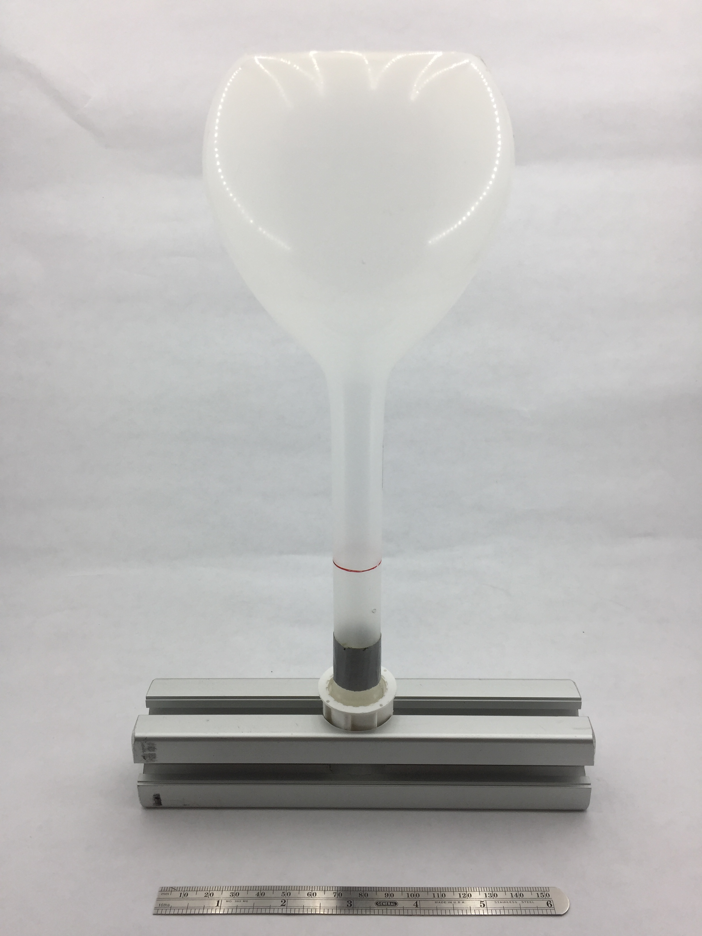

Figure S1. The non-printed single-rate Mariotte calibrator.

Our first printed design was a tapered cylinder with a cutout for an O-ring to seal to the volumetric flask. This design did not work. Despite the fact that the holes were made of different sizes to encourage flow of air and water in the small and larger holes, the pressure on both orifices would be equal because the difference in height was zero, frequently leading to a no-flow starting condition.

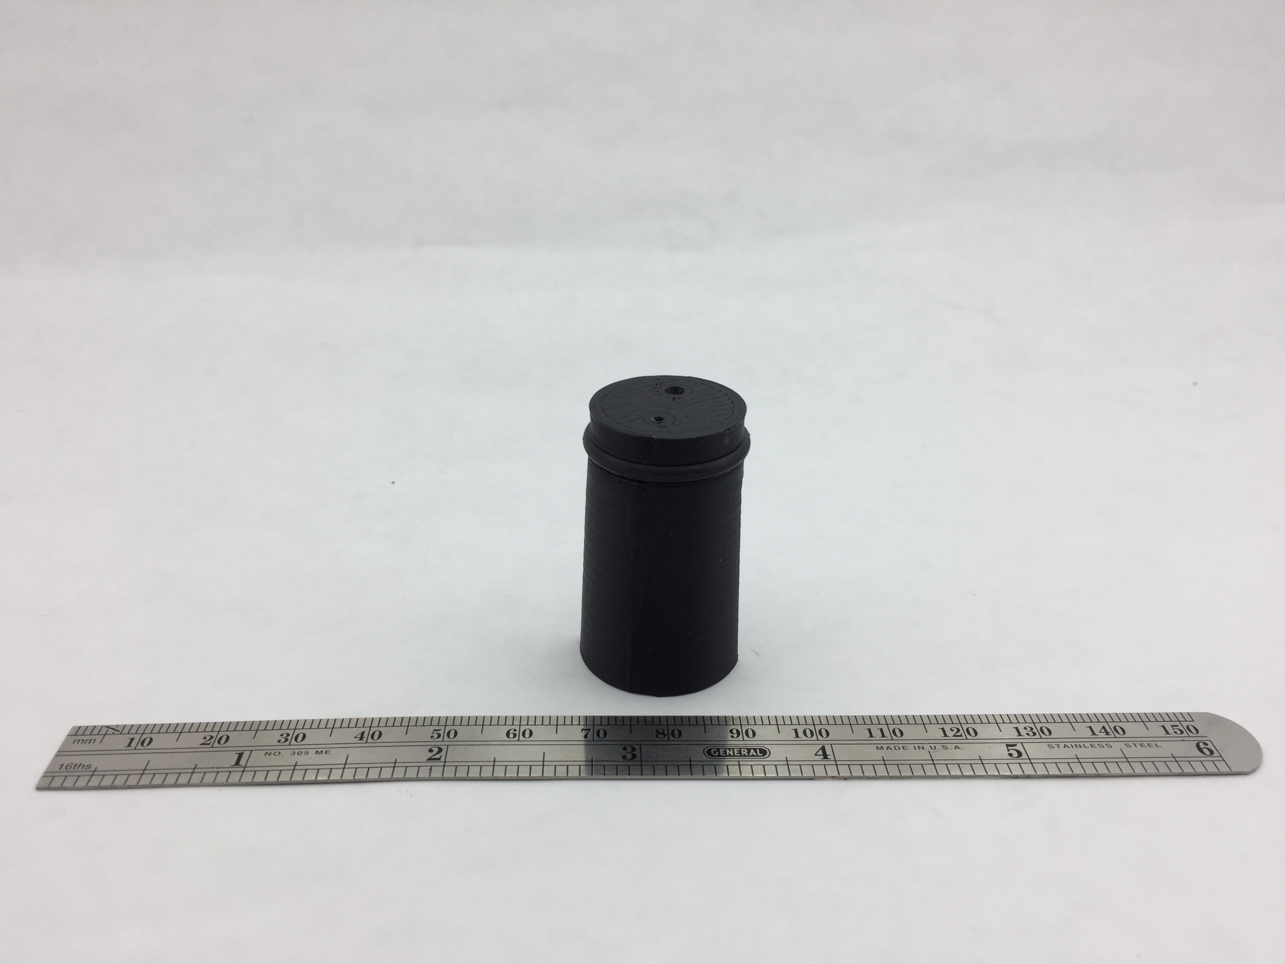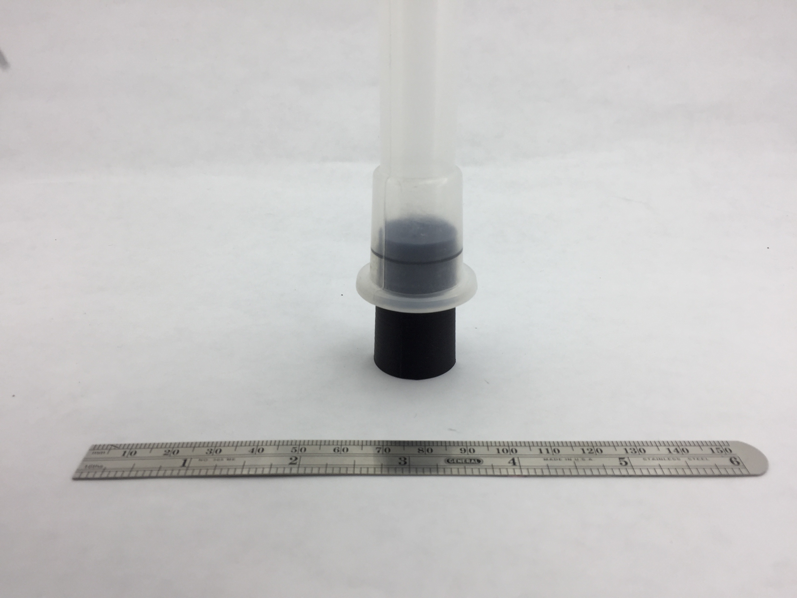

**Figure S2**. The single-rate Mariotte stopper with equal hole length (left: installed in volumetric flask; right, un-installed).

The second printed design had an extended air-inlet tube coming out the top of the stopper to develop a pressure difference between the two outlets (Figure S3). This design was an improvement over the first, but still had problems being inconsistent in the initiation of flow of air into the flask. Also, in the final few ml of water to be delivered the constant pressure condition would be lost, as the air entry port emerges from the water. One further disadvantage to this design was that the added extension to let air in could break easily. For field use, the design should be strong and maintenance-free.

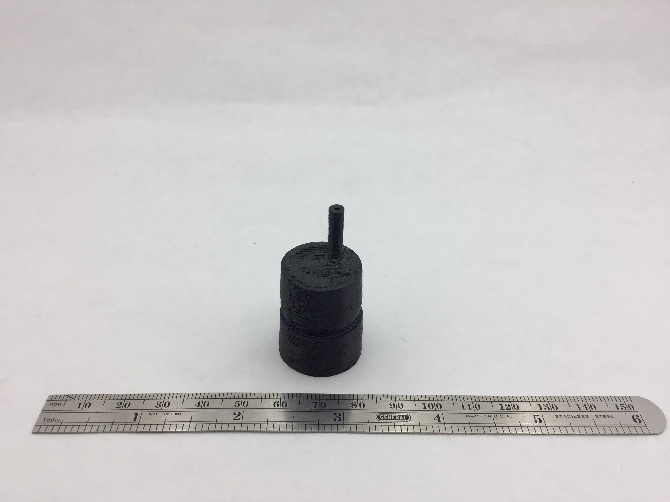

Figure S3. The second printed design with differentiated lengths of flow paths for air and water employing an extension tube into the water reservoir.

Our third design sought to provide greater differentiation of the air and water flow paths (Figure S4). To increase the distance between the two holes, half of the cylinder was omitted. This subtraction to the design gave the device consistent flow. A couple of components that were reconsidered were the tubes that were extending out of the valve on both extremes. These tubes where there to aid with the distance difference between both holes, but were still breaking off too easily.

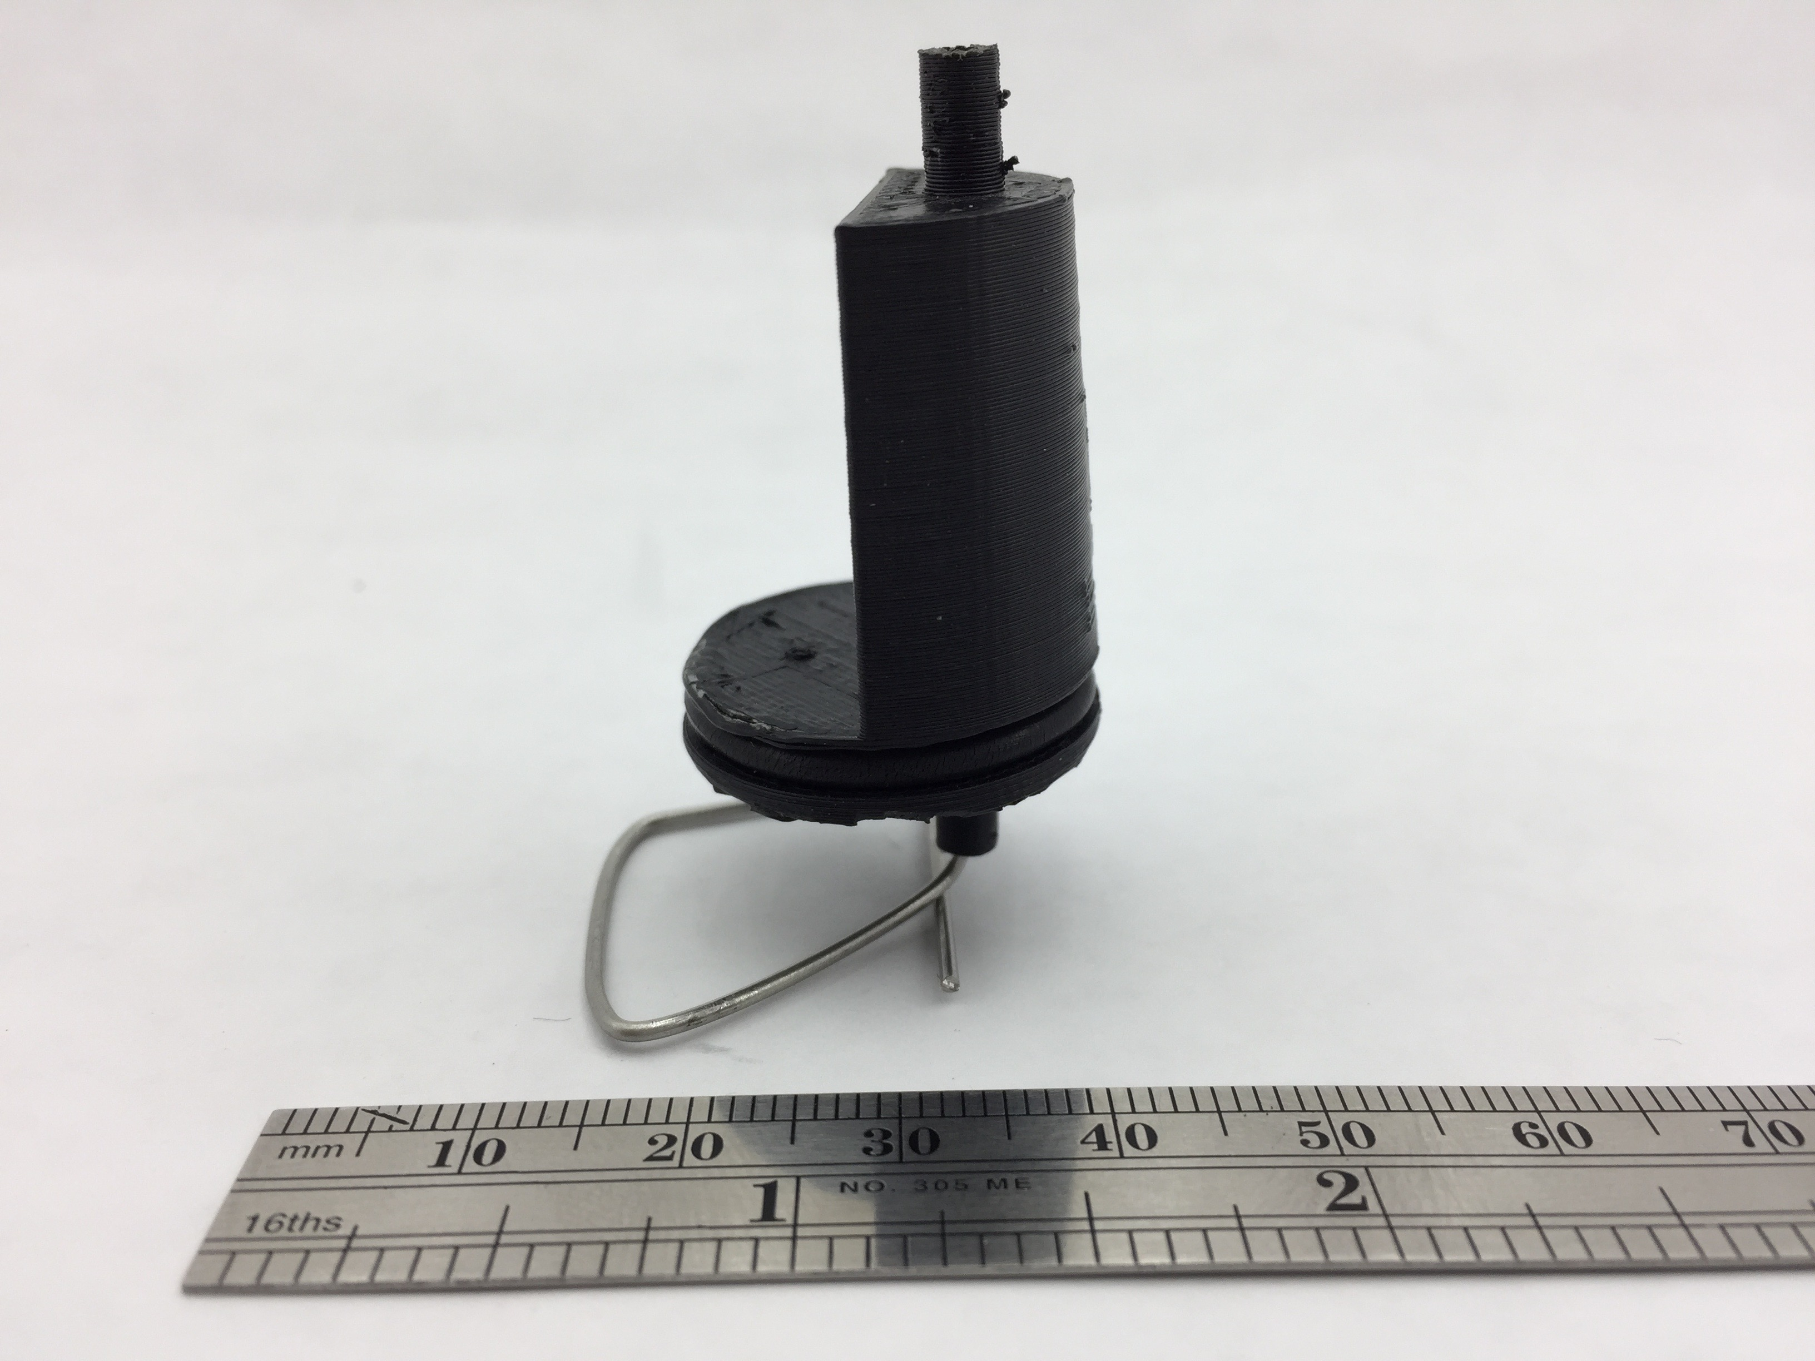

Figure S4. The third printed design, employing a split-stopper form but still with differential elevation of ports within the flask.

The fourth iteration gave better results. It omitted half the cylinder and had the air inlet raised 22mm above the water outlet. The only concern with this revision is that it was not consistent. It would last the longest and it would drip water at a constant rate but after a certain time it would stop. Timing is a crucial component of this piece, which needs to be as consistent as possible.

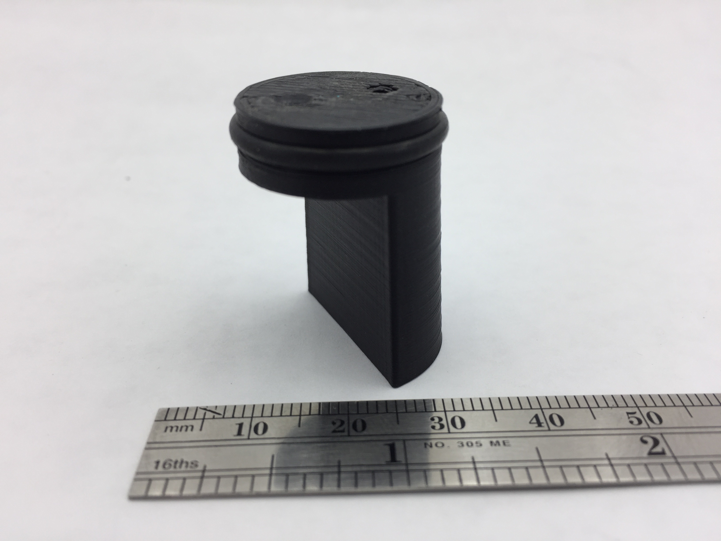

Figure S5. The fourth printed Mariotte stopper design employed equal port positions in the reservoirs, but un-equal positions outside the reservoir.

The final version devised has 60mm height distance from the air inlet and the water outlet (Figure S6). One of the advantages of this version is that it is one solid piece with no elements that can easily break off. This valve supplied a constant flow rate and allowed delivery of the entire contents of the 500ml flask. Three of these stoppers are located on the calibrator, and buttresses were added to provide mechanical stability to the design, as shown in Figure 2.

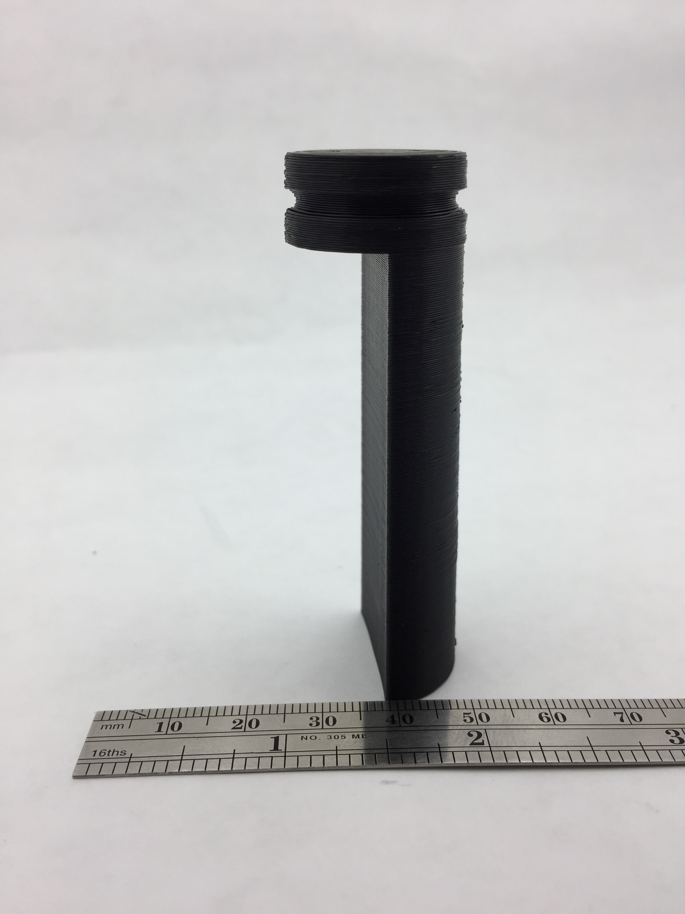

Figure S6. The final design of the Mariotte stopper with greatly differentiated tube lengths, and equal elevation ports within the volumetric flask.

S2. OpenSCAD code for the device

$fn = 100;

/****************************************************

Calibrator's Locations & Hole Sizes

****************************************************/

x = -30;//attachment movelocation

y = -5; //attachment move location

z = -5.75; //attachment move location

x2 = 5;//attachment movelocation

y2 = 30; //attachment move location

z2 = -5.75; //attachment move location

x3 = 5;//attachment movelocation

y3 = -30; //attachment move location

z3 = -5.75; //attachment move location

w_hole1 = .75;//radius of the first water hole

w_hole2 = .75;//radius of the second water hole

w_hole3 = 1;//radius of the third water hole

/****************************************************

Main base

****************************************************/

module mainbody_ring(){

difference(){

cylinder(11.5, 46, 46, center = true);

//translate([5+x,0+y,0])

//cylinder(60,h1,h1, center = true);// this is the hole on the right

translate([-5+x,0+y,0])

cylinder(60,w_hole1,w_hole1, center = true);// this is the hole on the left

translate([-5+x2,0+y2,0])

cylinder(60,w_hole2,w_hole2, center = true);

translate([-5+x3,0+y3,0])

cylinder(60,w_hole3,w_hole3, center = true);

}

}

module cut_out(){

difference(){

mainbody_ring();

translate([43,0,0])

cylinder(14,7.5,7.5, center = true);

}

}

module base(){

cut_out();

}

/****************************************************

Single Calibrator

****************************************************/

//Calibrator main body

module mainbody(){

cylinder(70,12,10.5);// main body (main cylinder) //center

/*translate([5,0,15])

cylinder( 30,2,2);//this is the cylinder that comes out of the main cylinder//center

*/

}

//Calibrator Holes

module holes(h1,h2){

difference(){

mainbody();

translate([5,0,0])

cylinder(170,h1,h1, center = true);// this is the hole on the right//center

translate([-5,0,0])

cylinder(170,h2,h2, center = true);// this is the hole on the left //center

}

}

//O-ring Cutout

module o_ring(h1,h2){

difference(){

holes(h1,h2);

rotate_extrude(convexity = 10)

translate([10.5, 72+z, 0+x])//ring extrude

circle(d = 2.4, center = true);

rotate_extrude(convexity = 10)

translate([11.5, 72+z,0+x])//square extrude

square([2,2.4], center = true);

}

}

module attach(h1,h2){

o_ring(h1,h2);

}

base();

/****************************************************

(3 Instances) Calibrators Hole Sizes & Half Cylinder Subtraction

****************************************************/

//attach(air,water)

translate([x,y,z])

difference(){

attach(.75,w_hole1);

translate([16,0,11])

cube([30,30,100],center = true);

}

//This cubes are for the suppport

translate([5,28,5])

cube([10,5,30]);

translate([0,10,5])

cube([5,10,30]);

translate([x2,y2,z2])

difference(){

attach(.75,w_hole2);

translate([16,0,11])

cube([30,30,100],center = true);

}

//This cubes are for the suppport

translate([5,-33,5])

cube([10,5,30]);

translate([0,-20,5])

cube([5,10,30]);

translate([x3,y3,z3])

difference(){

attach(.75,w_hole3);

translate([16,0,11])

cube([30,30,100],center = true);

}

//This cubes are for the suppport

translate([-29,-7,5])

cube([10,5,30]);

translate([-35,5,5])

cube([5,10,30]);